**7 клас І семестр**

**Speaking**

*Task . Imagine that while travelling during your holidays you took some photos. Choose one photo to present to your friend.*

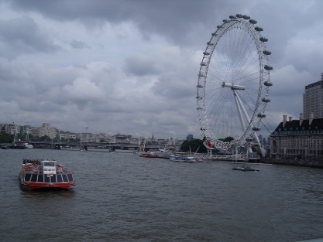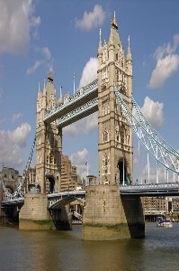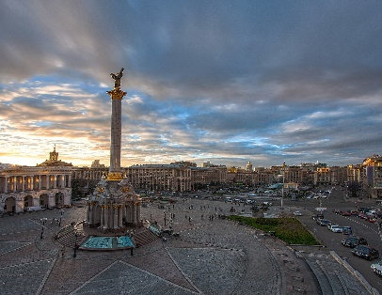

**In your talk remember to speak about:**

* **when** you took the photo
* **what/who** is in the photo
* **what** is happening
* **why** you took photo
* **why you decided to show the picture** to your friend

**You have to talk continuosly, starting with:**

*I've chosen photo number...*

 You can use such phrases:

* In the picture you can see…
* On the left / on the right of the picture…
* In the foreground of the picture…
* In the background of the picture…
* In the middle of the picture…
* At the top of the picture…
* At the bottom of the picture…
* Next to
* Behind
* Near
* Under
* In front of