Exercise 1. Complete the sentences.

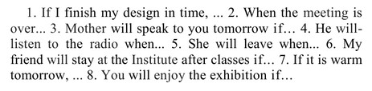

Exercise 2. Translate the sentences.

